Experiment 5
Prompt
“For the given student marks dataset, generate Excel formulas to calculate Total, Average, and Result. Total should add English, Maths, and Science. Average should calculate the mean of the three subjects. If the average is 50 or above, display Pass; otherwise display Fail.”
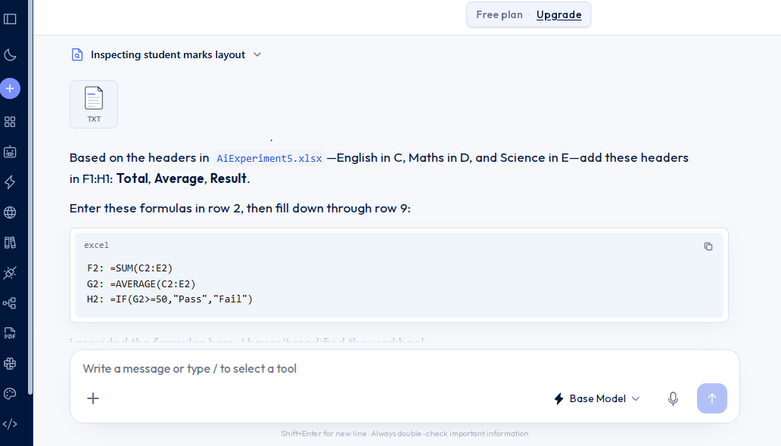

After applying formulas in Excel Workbook

Roll No | Student | English | Maths | Science | SUM | AVERAGE | RESULT
101 | Ravi | 78 | 85 | 72 | 235 | 78.33333333 | Pass
102 | Sita | 88 | 92 | 85 | 265 | 88.33333333 | Pass
103 | Arun | 65 | 70 | 75 | 210 | 70 | Pass
104 | Priya | 90 | 86 | 94 | 270 | 90 | Pass
105 | Kiran | 45 | 55 | 48 | 148 | 49.33333333 | Fail
106 | Anjali | 82 | 89 | 78 | 249 | 83 | Pass
107 | Rahul | 35 | 42 | 38 | 115 | 38.33333333 | Fail
108 | Divya | 95 | 93 | 89 | 277 | 92.33333333 | Pass

